**BODHISUKHA SCHOOL**

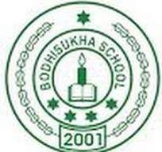

Name - Pritam Jaiswal,

Class - XII, Sec - B

Roll no. - 05

Subject - Computer science

Topic - Python

ACKNOWLEDGMENT

I would like to earnestly acknowledge the sincere efforts and valuable time

given by my respected Computer teacher Mrs.Shrabana Sengupta. Their valuable guidance and feedback have helped me

in completing this project.

Also, I would like to mention the support and consideration of my parents

who have always been there in my life.

Last but not the least, my friend(s) who have always been there with me.

Without them, I could never have completed this task.

Question 1. 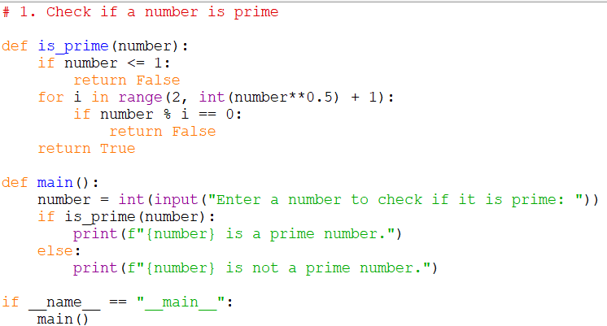

Output:

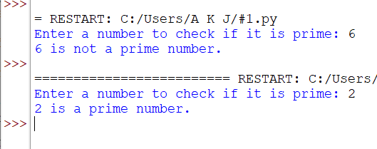

Question 2.

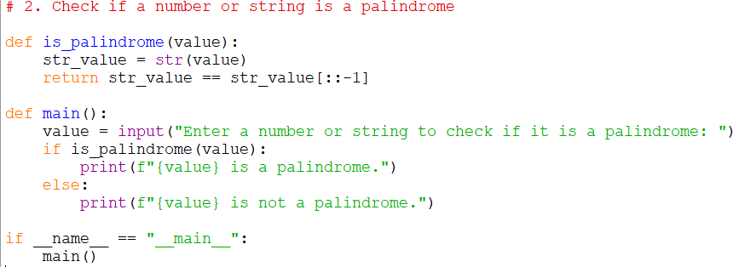

Output:

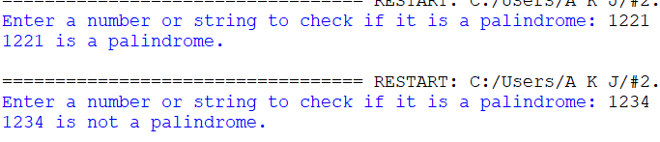

Question 3. 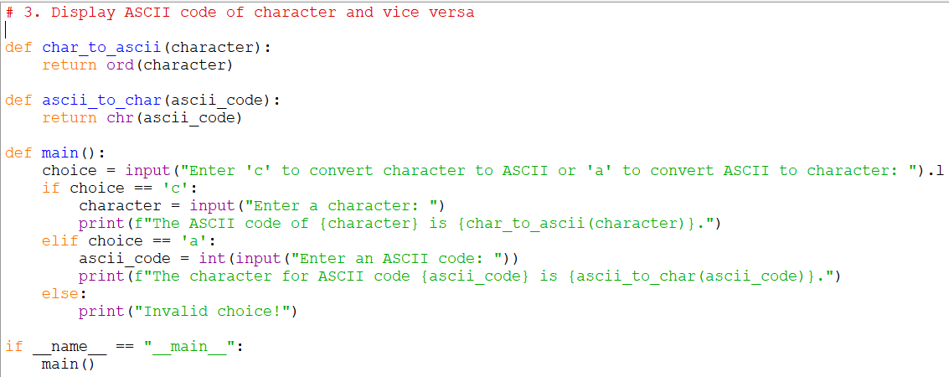

Output: 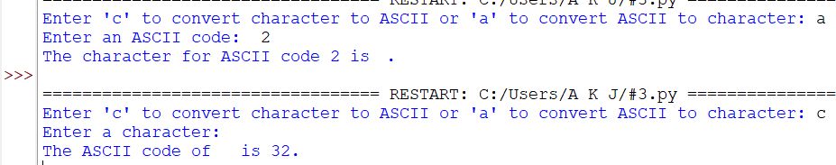

Question 4.

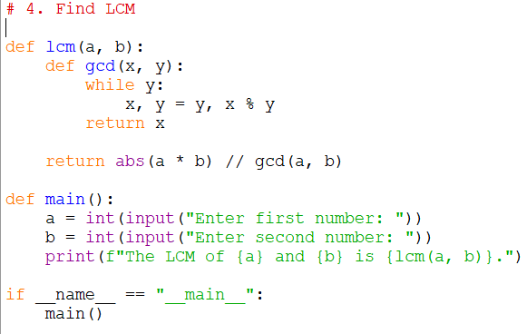

Output:

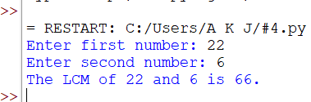

Question 5.

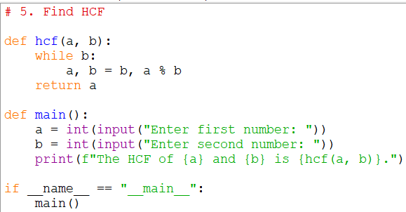

Output:

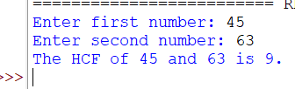

Question 6. 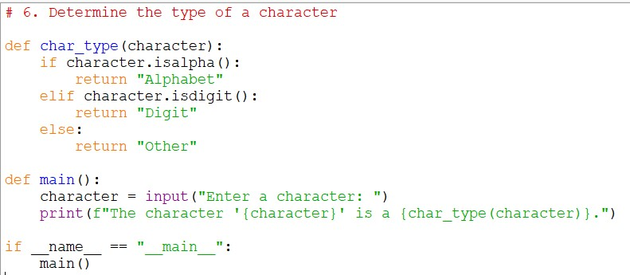

Output:

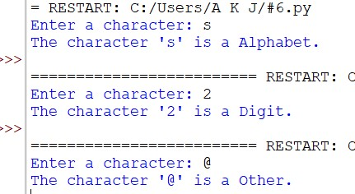

Question 7. 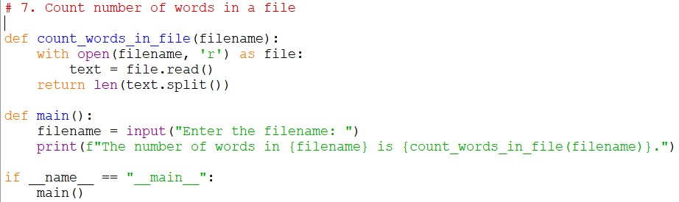

Output:

Question 8.

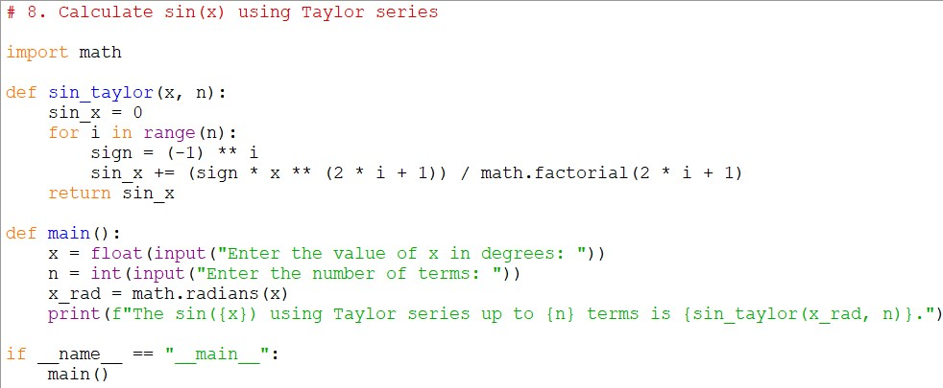

Output:



Question 9.

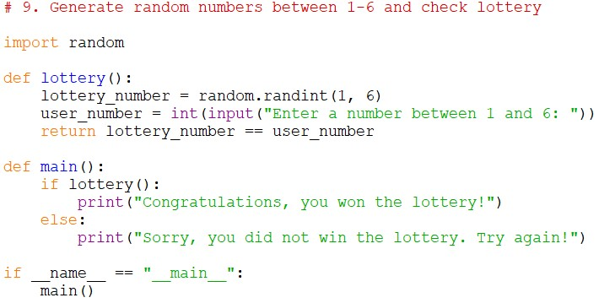

Output:



Question 10.

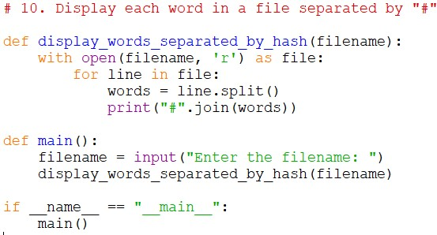

Output:

Question 11.

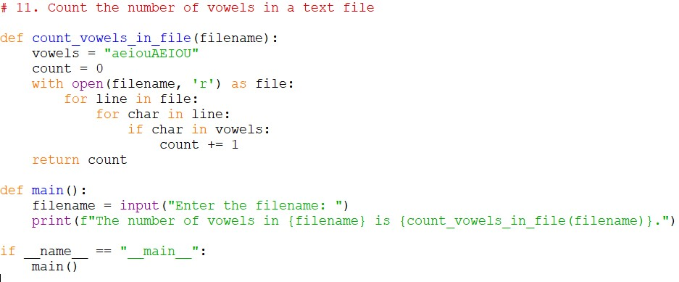

Output:

Question 12.

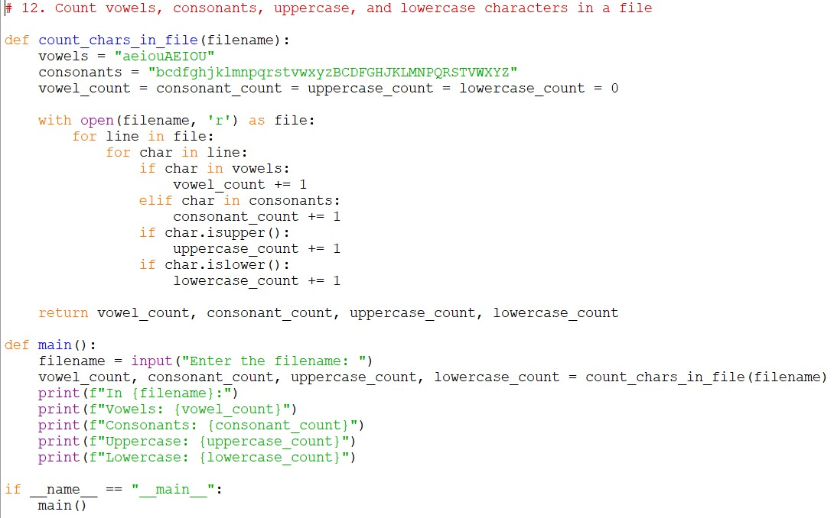

Output:

Question 13.

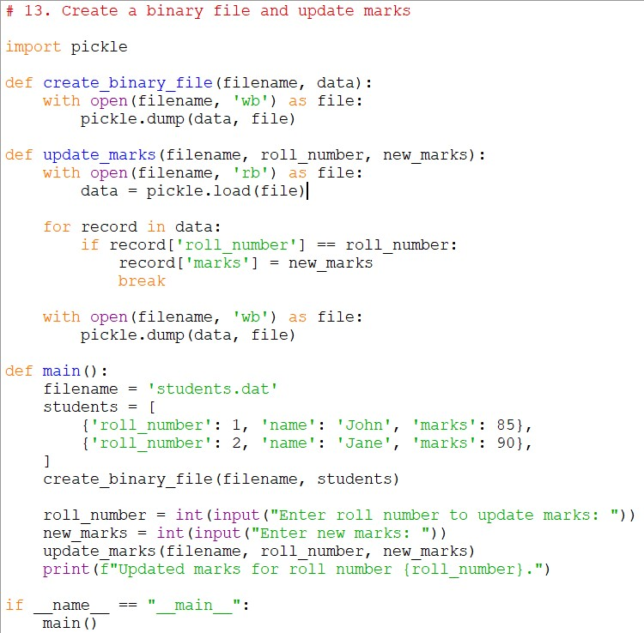

Output:

Question 14.

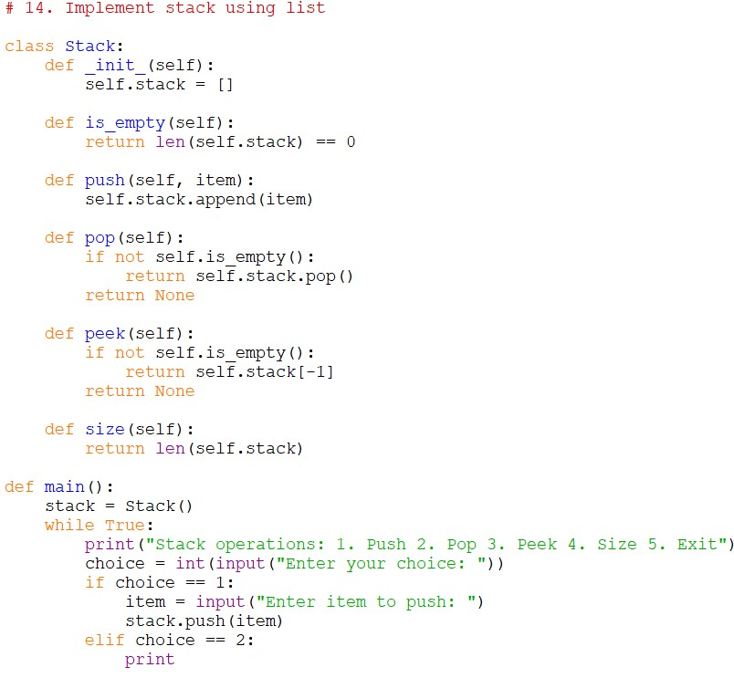

Output:

Question 15.

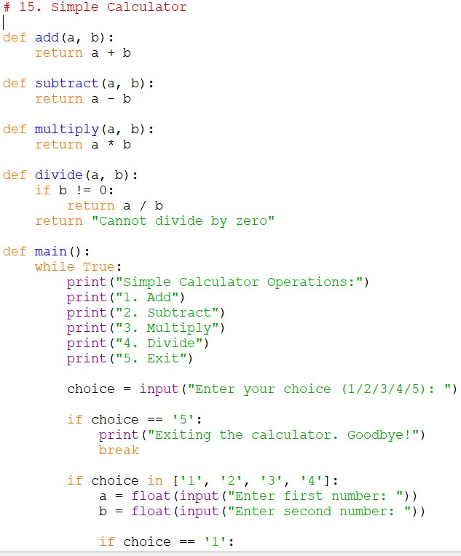

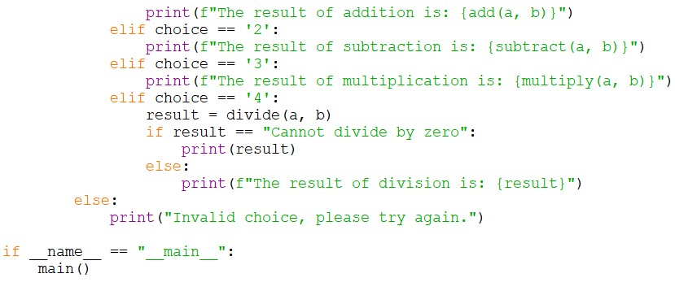

Output:

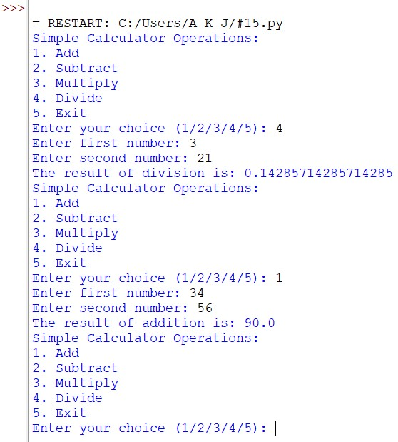

Question 16.

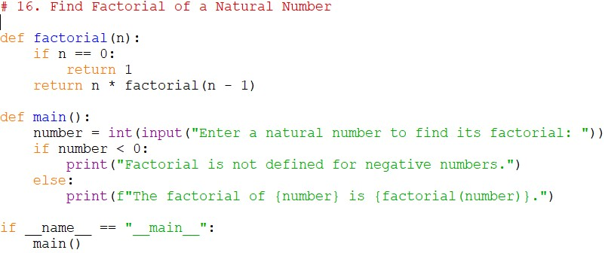

Output:

CERTIFICATE OF COMPLETION

This is to certify that Pritam Jaiswal, of Class XI, Sec B, Roll no. 05, has

successfully completed the practical file on Python, Information Practice. The

student has performed several python programing and demonstrated a commendable

understanding of Python programming concepts, and information practices.

This practical file, completed under the guidance of Miss

Shrabana Sengupta , includes a range of tasks and exercises that cover essential

aspects of Python programming.

_______________________

Date: _______________